***Dt : 28/10/2022***

***\*imp***

***Defining and raising User defined Exception:***

***step-1 : The user defined class must be extented from "java.lang.Exception"***

***class.(Pre-defined class)***

***step-2 : The user defined class must be declared with parameterized***

***Constructor with String as parameter,and this constructor will***

***pass msg to the ParentClass(java.lang.Exception)***

***step-3 : The program statements must be declared within the try block***

***step-4 : Define Exception_condition***

***step-5 : when Exception_Condition is true,then create object for User***

***defined class and while object creation pass exception_msg as***

***parameter***

***step-6 : use "throw" keyword to throw the object reference onto catch block***

***step-7 : display the msg from catch block***

***Ex:***

***IComparable.java***

***package test;***

***public interface IComparable {***

***public abstract int compare(int x,int y);***

***}***

***DemoException1.java(MainClass)***

***package maccess;***

***import test.*;***

***import java.util.*;***

***@SuppressWarnings("serial")***

***public class DemoException1 extends Exception***

***{***

***public DemoException1(String msg)***

***{***

***super(msg);***

***}***

***public static void main(String[] args) {***

***Scanner s = new Scanner(System.in);***

***try***

***{***

***System.out.println("Enter the value1:");***

***int v1 = s.nextInt();//Exception for NonInteger value***

***System.out.println("Enter the value2:");***

***int v2 = s.nextInt();//Exception for NonInteger value***

***if(v1<=0 || v2<=0)//Exception_condition***

***{***

***DemoException1 de = new DemoException1("Invalid values...");//con_call***

***throw de;//throwing object reference onto catch block***

***}***

***if(v1==v2)//Exception_Condition***

***{***

***DemoException1 de = new DemoException1("Values are equal...");***

***throw de;***

***}***

***System.out.println("====Choice====");***

***System.out.println("1.GreaterValue\n2.SmallerValue");***

***System.out.println("Enter the Choice:");***

***switch(s.nextInt())//Exception for NonInteger value***

***{***

***case 1:***

***IComparable gv = (int x,int y)->***

***{***

***if(x>y) return x;***

***else return y;***

***};***

***int r1 = gv.compare(v1,v2);***

***System.out.println("GreaterValue:"+r1);***

***break;***

***case 2:***

***IComparable sv = (int x,int y)->***

***{***

***if(x<y) return x;***

***else return y;***

***};***

***int r2 = sv.compare(v1, v2);***

***System.out.println("SmallerValue:"+r2);***

***break;***

***default:***

***System.out.println("Invalid choice....");***

***}//end of switch***

***}//end of try***

***catch(InputMismatchException ob)//Predefined Exception***

***{***

***System.out.println("Enter only Integer values...");***

***}***

***catch(DemoException1 de)//User defined Exception***

***{***

***System.out.println(de.getMessage());***

***}***

***finally***

***{***

***s.close();***

***}***

***}***

***}***

***Diagram:***

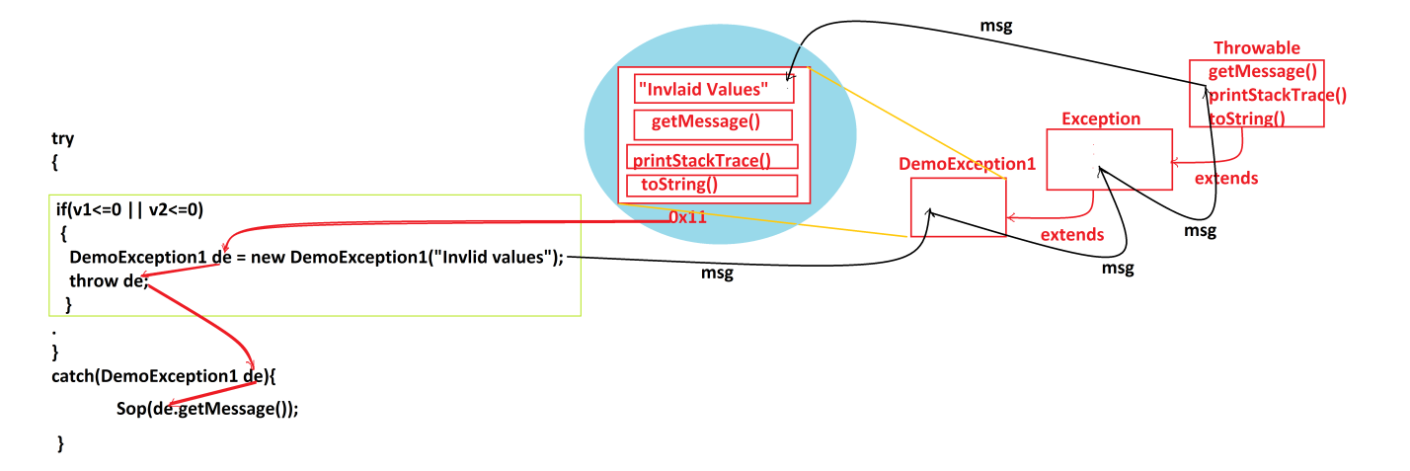

***===============================================================***

***Ex-program-2:***

***wap to read and display Employee details using Exception Handling process?***

***Note:***

***=>EmpId must 4 digits(AlphaNumeric)***

***=>EmpDesg must in SE or TE or ME***

***=>EmpBSal must min 12000/-***

***Designation.java***

***package test;***

***public class Designation {***

***public boolean verify(String desg) {***

***return switch(desg) {***

***case "SE":yield true;***

***case "TE":yield true;***

***case "ME":yield true;***

***default:yield false;***

***};***

***}***

***}***

***EmpMainClass.java(MainClass)***

***package maccess;***

***import java.util.*;***

***import test.*;***

***@SuppressWarnings("serial")***

***public class EmpMainClass extends Exception***

***{***

***public EmpMainClass(String msg)***

***{***

***super(msg);***

***}***

***public static void main(String[] args) {***

***Scanner s = new Scanner(System.in);***

***try***

***{***

***System.out.println("Enter the EmpId:");***

***String id = s.nextLine();***

***if(id.length()!=4)//Exception_Condition***

***{***

***EmpMainClass ob = new EmpMainClass("Invalid empId...");***

***throw ob;***

***}***

***System.out.println("Enter the EmpName:");***

***String name = s.nextLine();***

***System.out.println("Enter the EmpDesg:");***

***String desg = s.nextLine().toUpperCase();***

***Designation dg = new Designation();***

***boolean k = dg.verify(desg);***

***if(!k)//Exception_Condition***

***{***

***EmpMainClass ob = new EmpMainClass("Invalid designation...");***

***throw ob;***

***}***

***System.out.println("Enter the bSal:");***

***int bSal = s.nextInt();***

***if(bSal<12000)//Exception_Condition***

***{***

***EmpMainClass ob = new EmpMainClass("Invalid bSal...");***

***throw ob;***

***}***

***float totSal = bSal+(0.93F*bSal)+(0.63F*bSal);***

***System.out.println("EmpId:"+id);***

***System.out.println("EmpName:"+name);***

***System.out.println("EmpDesg:"+desg);***

***System.out.println("EmpBSal:"+bSal);***

***System.out.println("EmpTotSal:"+totSal);***

***}//end of try***

***catch(EmpMainClass ob)***

***{***

***System.out.println(ob.getMessage());***

***}***

***catch(InputMismatchException ime)***

***{***

***System.out.println("Enter only Integer value...");***

***}***

***finally***

***{***

***s.close();***

***}***

***}***

***}***

***==============================================================***

***Assignment:***

***Convert Student program into Exception Handling process.***

***=============================================================***